The board is working on several things including filling in the rest of the year with events. Mike Mesi has stepped up and taken on the Rustbuster, which will be on a Saturday. For some reason this first outdoor event seems to be a tough one to fill. Even so, it is time to get those vintage vehicles out from their winter slumber and give them a little exercise.

Don’t forget that we will be looking for all able-bodied members to volunteer some time to our annual car show. Remember, proceeds from this are how we are able to subsidize some of the events throughout the year. Lots of judges are needed and this is not a difficult task to assist with. There are also many other jobs which need people, too. If you can give an hour or two, please step forward and let any board member know, or sign one of the clipboards at our next two events.

A big thank you goes out to Mike Mesi, Cliff Schulz & Chuck Weimer for their dedication and early rising to get in line to book the same pavilion for our summer picnic. This is a good location and always a fun day.

It had been confirmed that the movie” The Natural”, will be rescheduled to the November meeting. I was surprised at the number of people who wanted to see this movie, both for the first time or revisit memories of when it was film here.

We are always looking for ideas and places to go, so if you have suggestion talk to any board member.

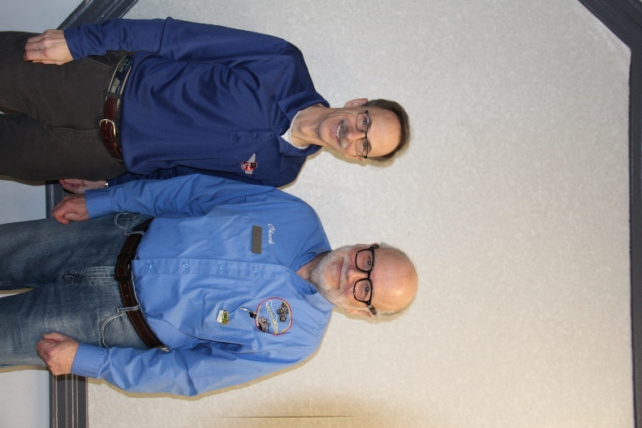More Thank Yous go out to Dave Kaplan & Chuck Facklam for a very informative presentation on the Playboy. I loved the home movies showing Dave’s grandfather and another company employee driving the Playboy on the back roads to see how it performed. A very interesting picture of the Playboy sitting in the driveway with the Thomas Rocket car sitting next to it! Chuck told of his hand in helping to restore the Thomas Rocket car back to its glory. It is nice to know that this and many of the Playboys are being saved for future generations to see.

Speaking of memories, I have seen a preview of the 2024 Year in Review slide show and again it will be another great presentation. Most people don’t realize the number of hours Barb Noonan puts into selecting, arranging, formatting and titling all those slides from Lon Wilson, into a terrific program. Hope to see you there.

Valerie Wilson